Chapter 17, Problem 72.

The signal displayed by a medical device can be approximated by the waveform shown in Fig. 17.86. Find the Fourier series representation of the signal.

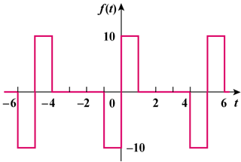

Figure 17.86
For Prob. 17.72.

